Bird’s music Episode#2: Gathering the orchestra

This week we started by collecting bird sounds from many bird families from all bird orders. Indeed, we want our sample to be as representative as possible of bird diversity. For most families, we tried to select species living in Europe or France. We also tried to match the species we chose with the ones held by the French Natural History Museum. This was done in order to facilitate the second part of the study, which will require the gathering of specimens’ syrinxes. However, some orders were exclusively birds from other continents, so we selected a few exoctic species in our database. We also noticed that vultures had no syrinx (Suthers, *How birds sing and why it matters,* 2004), but as we found no literature on how they produced sounds, we still collected sound samples for two vulture species.

We collected sounds from the library Xeno Canto. We then uploaded the sounds to our private online database on notion. For each recording, we informed the species, its family and order, the provenance of the recording, the sound ID number to help us find it back on Xeno Canto if we need to, and the type of sound (type of call, song, adult/juvenile, male/female). For practical reasons, we indexed all these data in a single table on the software notion. We have a final database of sounds for 130 bird species spread over 22 orders and 69 families.

Having built this database, we finished what composed the bulk of our project.

We then asked ourselves how we could analyze the mp3 files. We agreed, after reading Forstmeier et al. 2009, on trying to quantify the following acoustic variables :

Number of syllables   
 *Pitch :*Minimal fundamental frequency  
Maximal fundamental frequency  
Frequency modulation (sound “slope”)  
 *Tone :*Number of harmonics  
Relative intensity between harmonics  
Entropy (measure of sound pureness, Formeister et al. 2009)  
 *Rhythm :*Minimal, maximal, mean and standard deviation of syllable length   
Syllable rate

We wrote a code on R 3.6.2 to extract those variables from our files (MP3 recording). For that, we used the library soundgen (a library built to work with sounds). For now, our code allows us to get and append a csv file containing the following informations, meaned over each recording : name of the species, maximal, minimal, mean and standard deviation of syllable length, syllable rate, harmonics intensity, harmonics to noise ratio (HNR, intensity of the harmonics compared to the background noise), frequency of dominant harmonic, frequency of harmonics 1 to 3, entropy and sound slope.

The code also plots a “commented” sound diagram :

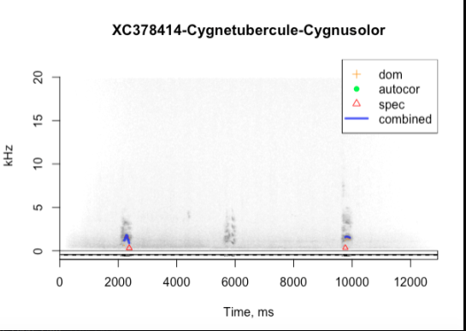

Figure 1 : Commented sound diagram for the Mute swan (Cygnus olor)  
In yellow : dominant “heard” frequency  
In green : autocorrection  
In red : theoretical dominant frequency calculated from the frequencies of the upper harmonics  
In blue : “trajectory” of the dominant frequency

We have to state that a bias comes from the fact that each variable is meaned over a whole sound file. But it is the easiest way we found to summarize the variables for each sound file, and not to have too many lines for each sound file. We also think of adding maximal, minimal and standard deviation values for each variable, in order to have a better description of the behaviour of each variable for each species.  
We still have some problems with the codes, as it sometimes returns NA for some variables. We thus have to analyze where this problem comes from and solve it. We also have to change the name of the columns of the csv file returned by the code, in order to make it more comprehensible.  
We also thought of a way to automatise the program to allow it to open each MP3 file without us doing it manually. However, because we need to create a list containing all the filenames of the recordings, as well as because we want to look at the plots, we ruled out this possibility for now.

To sum up, we were able to collect all the data sound we planned to collect, on most bird families, and to start building a code to analyse the sounds.

Next week, we will first have to correct the code, and eventually modify it to get a better description of each variable for each species. We then plan on analyzing all the sounds in the database using the code. Hopefully, we will at the end of next week - which will be for us the end of the project - have a csv file containing the analyzed variables of all the sound files of our database.